February 2026 EXTRA!!!!


Monthly Bulletin

We need help!
The Civic have told us they can no longer put chairs out for us or put them away. If you can come and help with this, please come along at 1.00 prior to the next meeting - March 3rd- to put the chairs out. This will enable us to organise signing in, answering queries, seeing to the speaker, setting up equipment including the kitchen and sorting membership payments.
Many thanks!

Annual Subscriptions

Annuals subscriptions are due on the 1st of April, 2026. This year we will be simplifying the the collection of subscriptions. Single membership £20, two persons living at the same address £30.

For existing members there will be no need to fill in the application form this year. Only new members will need to complete the application form.

Payment methods:

BACS (on-line banking) – if you are paying subs via BACS please note that our Bank Account details have changed, new details are:-

Name : U3A LONGRIDGE MEMBERSHIP FEES
Account No : 67468287
Sort Code : 089299

Please ensure that you fill in the reference box with your initial and surname

If your email address or gift aid statement has changed then please email the Membership Secretary on memsec4u3a@gmail.com

Cash and Cheques – We will be collecting cash and cheques at both the March and April monthly meetings. Please go to the dedicated tables in the area between the kitchen and bar at the Civic Hall. You will be asked to confirm your email address and gift aid position.

What if I cannot get to a meeting?
If you are unable to get to a meeting please email memsec4u3a@gmail.com to make alternative arrangements.
New Groups
PETANQUE
Following 2 Taster sessions held in January, a regular Petanque group is in the process of being set up for the morning of the 4th Wednesday in each month at Broughton & District Club. Further details will be publicised soon. Isobel Metcalfe and Barbara Griffiths are joint convenors. They are usually both at te monthly meetings
CHESS
A new Chess group is now taking place from 1.00pm to 3.00pm on 2nd and 4th Tuesdays in each month. Further details are already on our website. Go to: Chess - Longridge
David Metcalfe has agreed to be convenor for this group.
WALKING CRICKET
The Walking Cricket group hopes to use Longridge Sports Hall in March/ April for practice but this is dependent on the weather. If its bad weather Longridge Town FC will be using the Sports Hall for training. Also, we plan to enter a walking cricket team at the Accrington Walking Cricket Festival on the 19th May.

Monthly Meetings
We all know that costs are increasing! We are finding the costs of monthly meetings have increased – speakers fees, tea, biscuits etc.
From April 1st, we will be charging £1 admission to the meeting and giving each person a raffle ticket. The raffle prizes remain the same. For those of you who currently purchase a raffle ticket, this means no change at all.
We will also be charging £2 for visitors.
Having had conversations with other local U3As we have learned that we will be able to claim more back in gift aid if we implement this small change

u3a North West Region Summer Schools
Please check out the summer school courses at:
https://northwestregion.u3asite.uk/summer-school-2026/

Convenors – a reminder about PAT testing
Please take your electrical items to Longridge Electrical to arrange testing as soon as possible.
Thankyou to those of you who have already done this.
One of our new volunteers will be taking charge of the asset register so it would be a great help to get this done as soon as possible so it can be updated with the many new items purchased in recent months.

Remembrance Sunday.
We were very grateful to Anne Watton who represented our U3A at the wreath laying ceremony this year. We would like to hear from anyone who would be willing to lay our wreath this year. It might particularly be of interest to someone with links to the forces, either personally or through a friend of family member.
Please speak to one of the committee on a Tuesday meeting or mail Eleanor on chair4u3a@gmail.com

Speaker at our February meeting- Jennifer Ray - "A Lancashire Lass".
Jennifer gave a fascinating talk and Rob Kemp has made a list of all the places she mentioned, together with links to get more information.
Many thanks to Rob!!

Longridge u3a monthly meeting, 3 Feb 2026 – Note of locations – Apologies if there are any errors!
The Big Stone (Bentham)  https://www.tathamfells.me.uk/?page_id=286 | 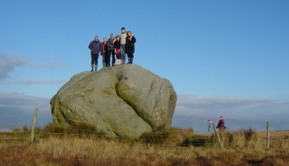
The Bowder Stone (near Keswick)  https://www.keswick.org/explore/not-to-miss/the-bowder-stone | 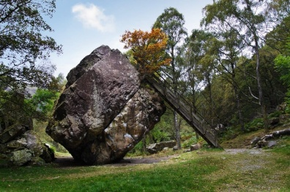
The Druids Tree and the Fish Stones  https://www.thenorthernantiquarian.org/2009/08/18/druids-oak-caton/ | 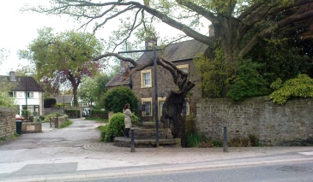
Witch Wood (Lytham)  https://www.visitlytham.info/about/parks/witch-wood/ | 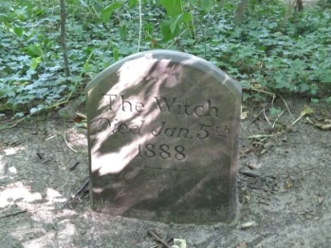
Cromwell’s Bridge  https://www.visitnorthwest.com/sights/cromwells-bridge/ | 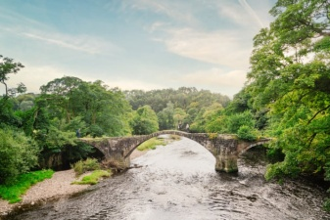
Bolton Hall, now Henry’s Mews (Bolton by Bowland)  https://redrosecollections.lancashire.gov.uk/view-item?i=267768&WINID=1770140008000 | 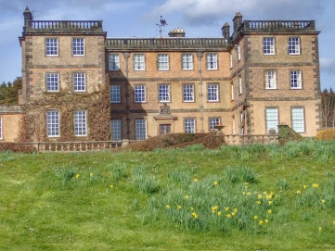
St Peter’s and St Paul’s Church (location?)  https://www.bing.com/maps/search?mepi=0%7ELocal%7EEmbedded%7EEntity_Vertical_List_Card&ty=17&poicount=18&sei=0&FORM=MPSRPL&q=st+peters+and+st+pauls+church&secq=Roman+Catholic+Church+of+St+Peter+%26+St+Paul+st+peter+and+st+paul+s+church&sece=ypid.YNBCAFF048F0ADA76B&ppois=53.81746292114258_-2.527681827545166_Roman+Catholic+Church+of+St+Peter+%26+St+Paul_YNBCAFF048F0ADA76B%7E53.77133560180664_-2.7611424922943115_St.+Peter+%26+St.+Paul+Catholic+Church_YNF3CBB3895C9BF8C2%7E&segment=Local&cp=53.817463%7E-2.527682&lvl=11&style=r | 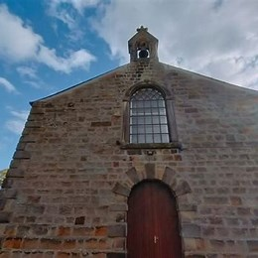
Pudsey’s Leap / Rainsber Scar  https://northwestnatureandhistory.co.uk/2023/10/19/unnatural-histories-pudseys-leap-and-the-fairys-silver-bit/ | 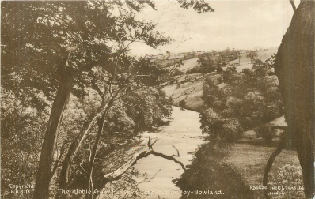
Folly (Coniston)  https://www.lakesguides.co.uk/html/lgaz/lk24293.htm | 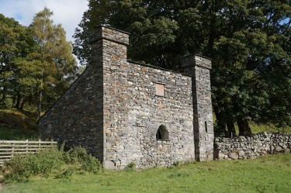
C8 Viking Loki Stone (Kirby Stephen)  https://www.megalithic.co.uk/article.php?sid=26310 | 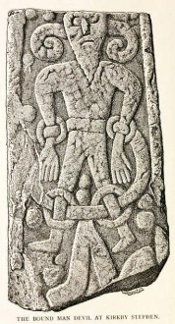
Ancient Graves (Heysham)  https://thejournalofantiquities.com/2017/05/29/st-patricks-chapel-and-rock-graves-heysham-lancashire/ | 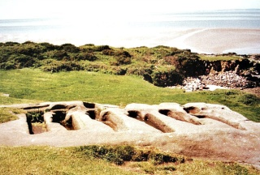
St Peter’s church (Heysham)  https://heyshamparish.org.uk/st-peters-church/ | 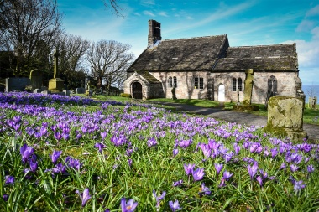
Piel Island (across from Fleetwood)  https://en.wikipedia.org/wiki/Piel_Island | 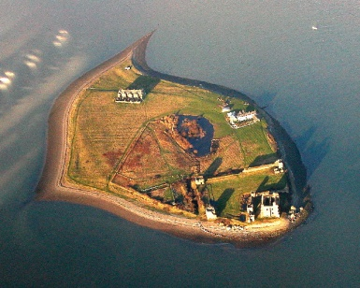
Jubilee Tower (Darwen?)  https://www.darwentower.com/ | 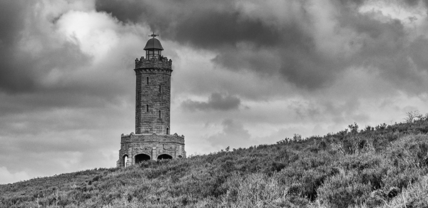
St John the Baptist (Tunstall)  https://en.wikipedia.org/wiki/St_John_the_Baptist%27s_Church,_Tunstall | 